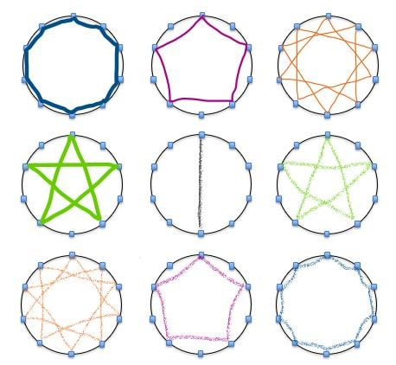
CONCEPTUAL MATH LEVEL I—THE BASE TEN CIRCLES –

Tap and then map the visual representation of the multiples of 1 on the base ten circle.

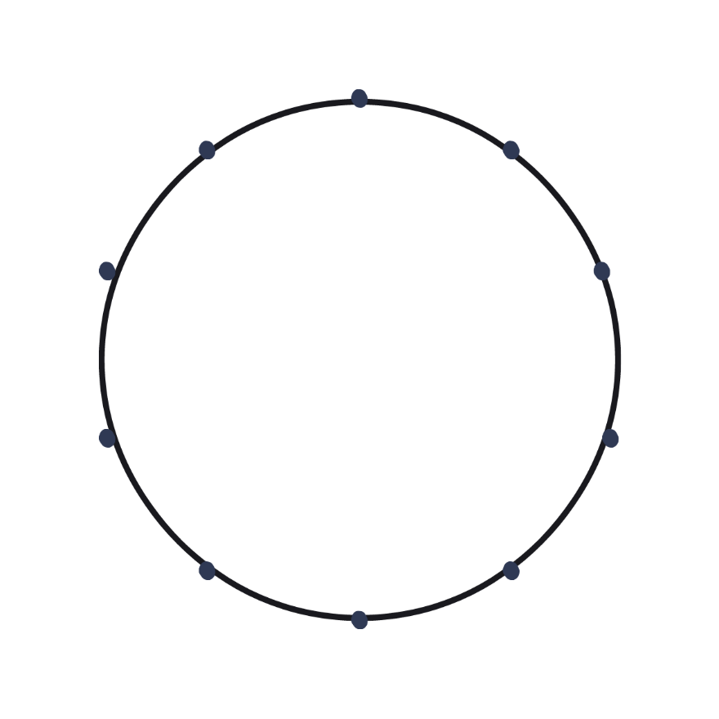

Tap and then map the visual representation of the multiples of 2 on the base ten circle.

Tap and then map the visual representation of the multiples of 3 on the base ten circle.

Magic Square
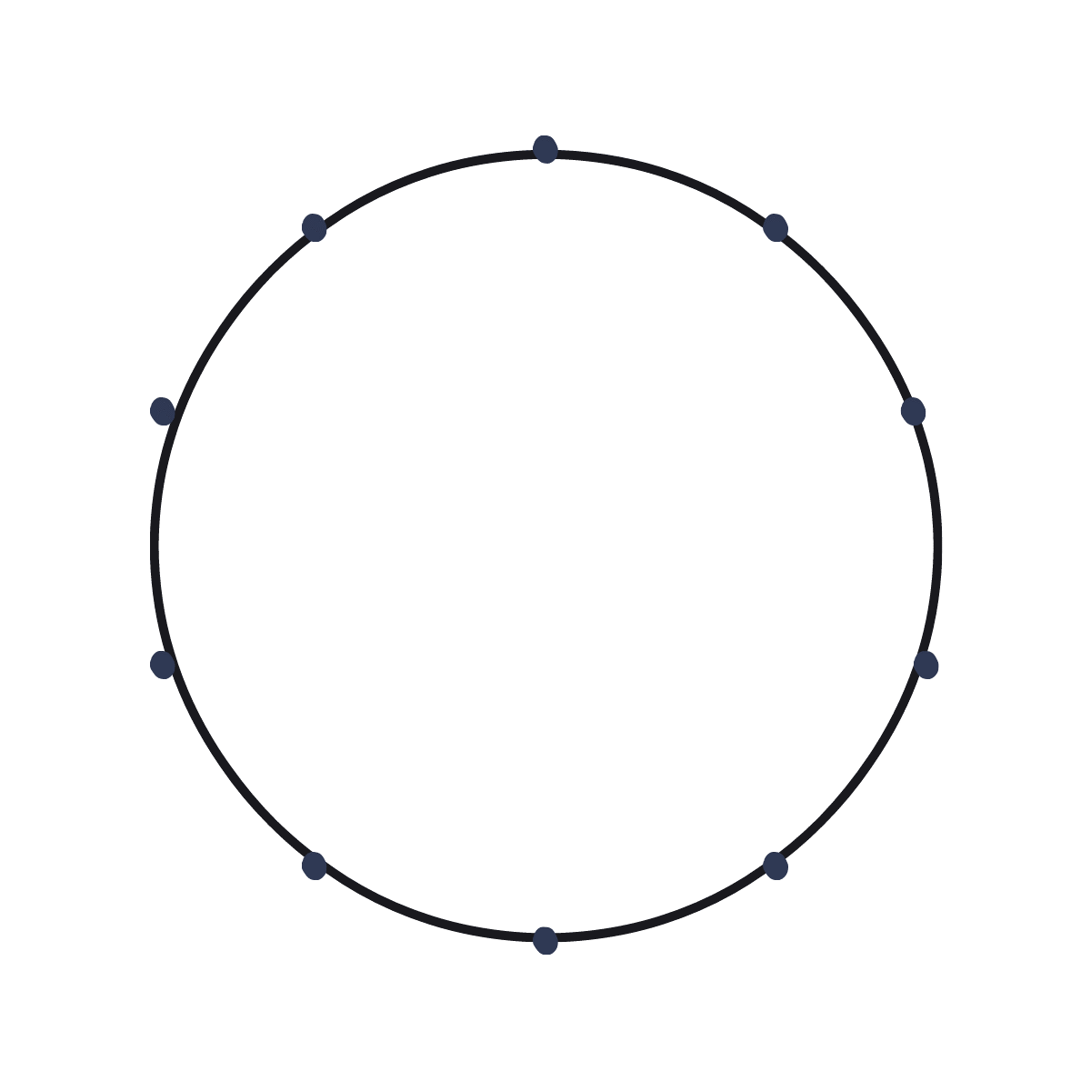

Tap and then map the visual representation of the multiples of 4 on the base ten circle.

Tap and then map the visual representation of the multiples of 5 on the base ten circle.
Tap and then map the visual representation of the multiples of 6 on the base ten circle.

Tap and then map the visual representation of the multiples of 7 on the base ten circle.

Magic Square

Tap and then map the visual representation of the multiples of 8 on the base ten circle.

Tap and then map the visual representation of the multiples of 9 on the base ten circle.

What are two multiples that look the same? Map them next to one another.

What are two other multiples that look the same? Map them next to one another.

What are two more multiples that look the same? Map them next to one another.

THE ARRAY OF NINE
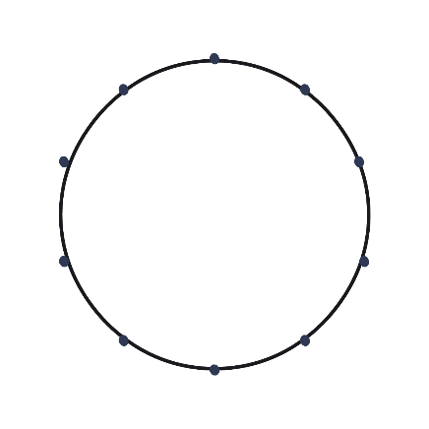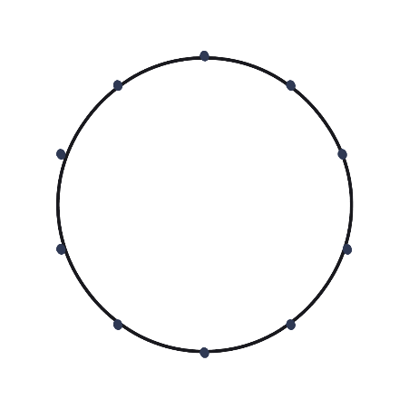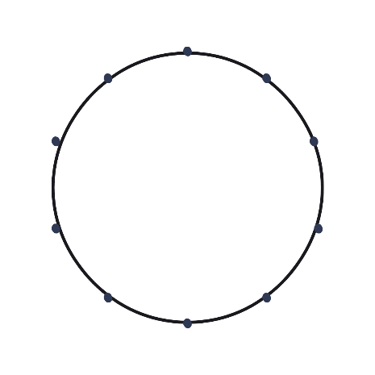
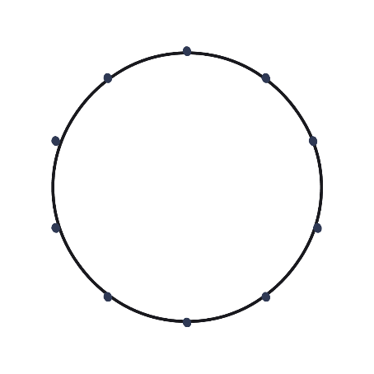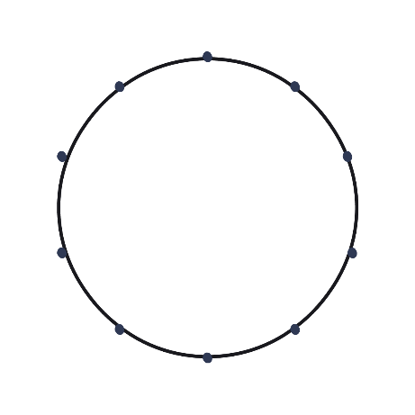
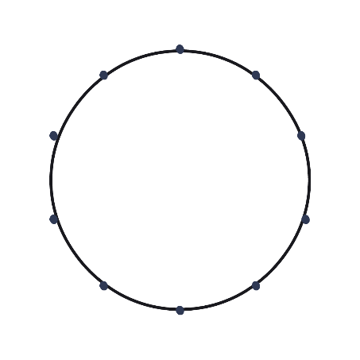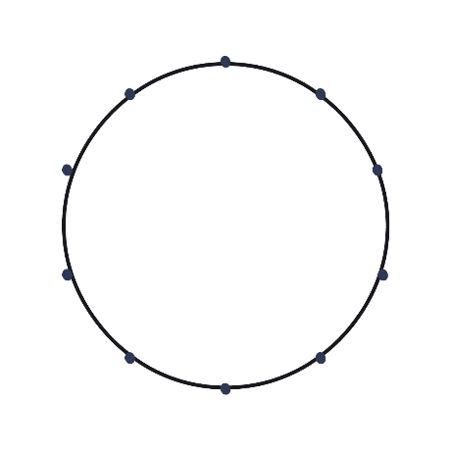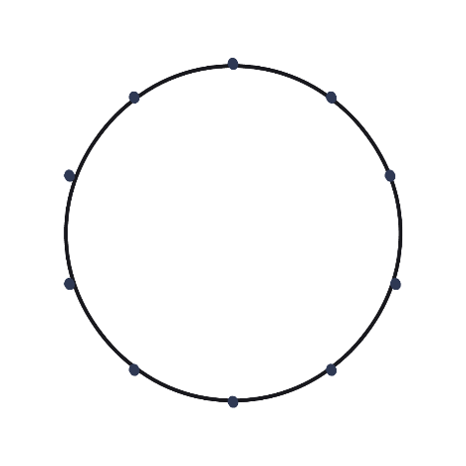
ONE-HUNDRED CHALLENGE

 | 1 | 2 | 3 | 4 | 5 | 6 | 7 | 8 | 9
Date
Completed

Observer
Initials

The ball must be thrown without dropping, and each multiple must be recited correctly up to 100. Any mistakes result in starting from the beginning again at zero.
*Alternate rule: When the ball is dropped, the one who dropped it must factor the number it was dropped on, down to it’s prime factorization
Challenge rule: At each 0 value, the recipient must say what the multiple was for that particular based number (e.g. when the counting by fours when someone gets to 20, the must say “Four times Five!”, or likewise when they get to 40, it is “Four times 10”, at 60, someone shouts “four time 15,” etc. This can be shouted in unison, or assigned to the person who throws or who receives the ball.

What patterns did you notice when completing each number?

PRIME NUMBERS TABLE

1 | 2 | 3 | 4 | 5 | 6 | 7 | 8 | 9 | 10
11 | 12 | 13 | 14 | 15 | 16 | 17 | 18 | 19 | 20
21 | 22 | 23 | 24 | 25 | 26 | 27 | 28 | 29 | 30
31 | 32 | 33 | 34 | 35 | 36 | 37 | 38 | 39 | 40
41 | 42 | 43 | 44 | 45 | 46 | 47 | 48 | 49 | 50
51 | 52 | 53 | 54 | 55 | 56 | 57 | 58 | 59 | 60
61 | 62 | 63 | 64 | 65 | 66 | 67 | 68 | 69 | 70
71 | 72 | 73 | 74 | 75 | 76 | 77 | 78 | 79 | 80
81 | 82 | 83 | 84 | 85 | 86 | 87 | 88 | 89 | 90
91 | 92 | 93 | 94 | 95 | 96 | 97 | 98 | 99 | 100

